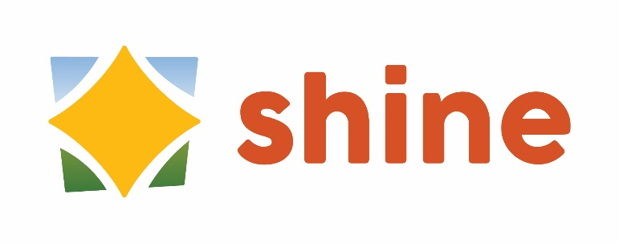
Regular Meeting
Meeting Agenda
January 27, 10:30 a.m. to 11:30 a.m.

Blake Room, Somers Public Library

Cancelled
Weather Closure

NEXT Regular MEETING
February 24, 10:30 to 11:30
Blake Room, Somers Public Library

Future Meetings
March 24
April 28
May 26
June 23
July – no meeting
August – no meeting
September 22
October 27
November 24
December – no meeting

